- What is a Structure, Declaration, accessing the structure members using structure variables, types of structures and explain one example

- Structure is a Derived Data type , and collection of dissimilar data items.
- syntax:
struct structure name
{
Datatype1 member 1;
Datatype2 member 2;
…………………….
…………………….
};
Ex:- struct student
{
char name[20];
int id;
};
struct is a keyword , name and id are members of the structure ,
Every structure ends with a semicolon
Struct student s1;
S1 is a structure variable , student is the tag name of the structure

- In the above declaration , student tag name is optional , which means a structure can be declared with out any name called anonymous strcuctures.
Ex: - struct
{
char name[20];
int id;
};
- The size of a structure variable is sum of its size occupied by each member of the structure.
Ex:- struct emp
{
Int id;
Char name[20];
Float sal;
};
struct emp e;
Printf(“%d”,sizeof(e)); prints ( 20+2+4) = 26
- If one or more members of a structre are pointer to the same structure , the structure is known as Self – Referential Structure.
Ex: -
struct student
{
Int id;
Char name[20];
struct student *next;
};
6. The Operators that were used with structures are .(dot /period) and -> (arrow / point to).
Ex;- struct emp
{
Int id;
Char name[20];
Float sal;
};
struct emp e,*eptr;
In the above example e is a structure variable , To access the members of the structure using e we have to use .(dot) operator.
e.id=12;
e.sal=1234.56;
In the above example eptr is a pointer to structure. To access the members of the structure using eptr we have to make use of -> operator.
eptr = &e;
printf(“%d %f”,eptr->id, eptr->sal);
- A Structure inside another structure is called nested Structure.
Ex - struct Emp
{
Char name[20];
Int id;
Float sal;
Strcut
{
Float basic,da,hra;
Float lic,pt,pf;
}nsv;
}osv;
In the above structure osv is the outer structure variable ,
Nsv is the nested structure variable , to access the members of the nested structure using outer structure variable osv follow the syntax below:
osv.nsv.basic=10000;
osv.nsv.lic=500;
- One structure can not be a member of the same structure .
Ex:- Struct student
{
Int id;
Char name[20];
Struct student next;
};
In the above example , there is a error , a structure can not have a member of itself ,because the size of that member is unknown at that time.
struct emp e[100]; e is an array of structure with 100 records.

/*write a program to find out the students marks total,avg by using structures */
struct student
{ char name[20];
char branch[10];
int rollno;
int a,b,c,d,e,f,g,total;
float avg;
} s1;
void main()
{ clrscr();
printf("\n Enter Student Name:");
scanf("%s",s1.name);
printf("\n Enter roll Number:");
scanf("%d",&s1.rollno);
printf("\n Enter branch:");
scanf("%s",&s1.branch);
printf("\n Enter the marks of the student");
scanf("%d%d%d%d%d%d%d",&s1.a,&s1.b,&s1.c,&s1.d,&s1.e,&s1.f,&s1.g);
s1.total = s1.a+s1.b+s1.c+s1.d+s1.e+s1.f+s1.g;
s1.avg=s1.total/6;
printf("\n Name of the student:%s\n",s1.name);
printf("\n Roll No: %d Branch :%s\n",s1.rollno,s1.branch);
printf("\n Total Marks:%d \n",s1.total);
printf("\n Average:%f\n",s1.avg);
getch();
}

/* program to read and display employee details using structures */

#include<stdio.h>
#include<conio.h>
struct Employee
{
char name[20];
int id;
char dept[20];
float sal;
int age;
char gender;
} emp1, emp2,emp3;
void main()
{
clrscr();
printf("Enter the details of 1st employee\n");
scanf("%c%s%d%s",&emp1.gender,&emp1.name,&emp1.id,
&emp1.dept);
scanf("%f%d",&emp1.sal,&emp1.age);
printf("employe details\n");
printf("Name:%s\n",emp1.name);
printf("Id: %d\n",emp1.id);
printf("Department:%s \n Salary :%f\n",emp1.dept,emp1.sal);
printf("Age:%d\n Gender:%c\n",emp1.age,emp1.gender);
getch();
}

- What is a Union , What are the differences between unions and structures, explain with one example

- Union is also similar to Structure , collection of different data items in which each member shares the same block of memory.
      - Ex:- Union Emp
        - {
          - char name[20];
          - int id;
          - float sal;
        - };
      - Union Emp e;
- In the above Example e is a union variable , to this e, 20 bytes will be allocated as the maximum size of all the members in the union is 20 (name)
- The same 20 bytes is used to store name, id and sal ,but one at any time.
- Union cannot hold all the values at a time. It contains the last recent written value , and the same value will be maintained for all the members .

Differences between Structures and Unions

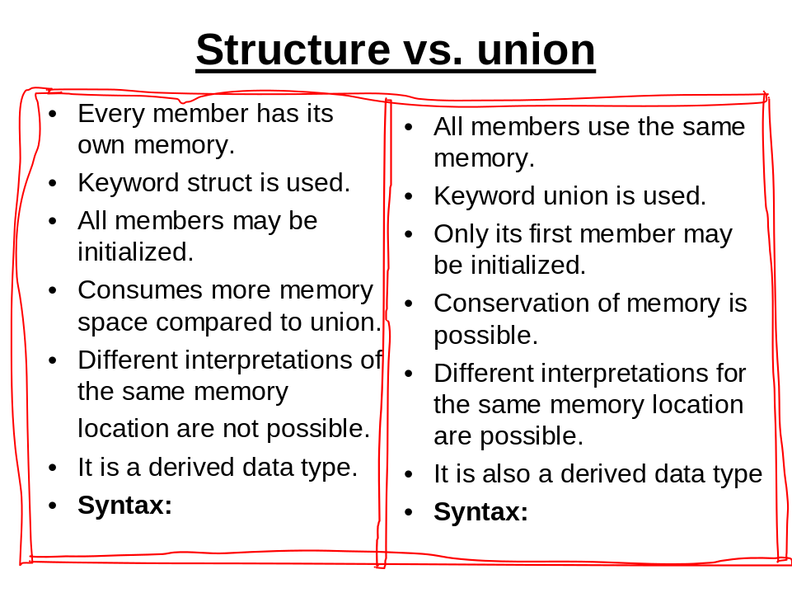
struct Emp union Emp
{ {
char name[20]; char name[20];
int id; int id;
float sal; float sal;
}e; }d;

Sizeof e: 26 sizeof d: 20
More memory required Conservation of Memory

- a) Explain the concept of Bit fields in structures with one example

BIT FIELDS:
Bit Field is a structure member that contains specified number of bits . we can declare a bit field to contain 1 bit ,2 bits, or what ever the number of bits required to hold the data stored in the field / example
struct Application
{
int gender:1;
int mar_stat:2;
int qual:1;
}app;
For app variable 1 byte will be reserved, among 1 bit is used to store gender ( 0 for female , 1 for male) , 2 bits for martial status ( 0 – for married, 1 for single , 2 for Others) , 1 bit for qualification ( 0 – graduation , 1 for Post graduation ) .
Some Important points related to Bit fields:
- Bit fields can be signed or unsigned integers
- Bit fields can not be used in a union
- Bit fields can not be float
- Bit field – set of adjacent bits in a computer word of memory
- A Bit field can be of width 0;

/* program to explain the concept of bit fields in structures */

#include<stdio.h>
#include<conio.h>
struct App
{
char name[20];
unsigned gen:1;
unsigned ms:3;
unsigned q:1;
};
void main()
{
struct App a;
clrscr();
printf("Enter the name of the student\n");
gets(a.name);
printf("Enter gender\n");
a.gen=0;
a.ms=0;
a.q=0;
printf("Name of the Applicant:%s\n",a.name);
printf("Gender:");
switch(a.gen)
{
case 0: printf("FEMALE"); break;
case 1: printf("MALE"); break;
}
printf("\n");
printf("Martial Status:");
switch(a.ms)
{
case 0: printf("SINGLE"); break;
case 1: printf("MARRIED"); break;
case 2: printf("WIDOWER"); break;
case 3: printf("DIVORCEE"); break;
case 4: printf("OTHERS"); break;
}
printf("\n");
printf("QUALIFICATION:");
switch(a.q)
{
case 0: printf("GRADUATE"); break;
case 1: printf("POST GRADUATE"); break;
}
printf("\n");
getch();
}

3. b) Explain Self referential Structures with one example

If one or more members of a structure are pointer to the same structure , the structure is known as Self – Referential Structure.
Ex: -
struct student
{
int id;
char name[20];
struct student *next;
};
/* Write a program to explain the concept of Self referential structures */

#include<stdio.h>
#include<conio.h>
#include<alloc.h>
struct class
{
char name[20];
int id;
struct class *next;
}*head=NULL;
void adddata(struct class *);
void display(struct class *);
void main()
{
int i,n;
clrscr();
printf("Enter number of students\n");
scanf("%d",&n);
for(i=0;i<n;i++)
adddata(head);
display(head);
getch();
}
void adddata(struct class *r)
{
struct class *temp = (struct class *) malloc(sizeof(struct class ));
struct class *p = (struct class *) malloc(sizeof(struct class ));
printf("Enter details of student\n");
scanf("%s%d",&temp->name,&temp->id);
temp->next = NULL;
if(head==NULL)
{
head=temp;
}
else
{
for(p=r;p->next!=NULL;p=p->next);
p->next = temp;
}
}
void display(struct class *r)
{
struct class *p = (struct class *)malloc(sizeof(struct class ));
for(p=r;p!=NULL;p=p->next)
printf("%s -- %d\n",p->name,p->id);
}

4 a) Write a C program to perform complex arithmetic using structures and functions
b) Write a C program to perform Bank transactions using Structures

/* Write a C program that uses functions to perform the following operations:
i) Reading a complex number
ii) Writing a complex number
iii) Addition of two complex numbers
iv) Multiplication of two complex numbers */

#include<stdio.h>
#include<math.h>

void arithmetic(int opern);

struct comp
{
double realpart;
double imgpart;
};

void main()
{
int opern;
clrscr();
printf("\n\n \t\t\t***** MAIN MENU *****");
printf("\n\n Select your option: \n 1 : ADD\n 2 : MULTIPLY\n 0 : EXIT \n\n\t\t Enter your Option [ ]\b\b");

scanf("%d",&opern);

switch(opern)
{
case 0:
exit(0);
case 1:
case 2:
arithmetic(opern);
default:
main();
}

}

void arithmetic(int opern)
{

struct comp w1, w2, w;

printf("\n Enter two Complex Numbers (x+iy):\n Real Part of First Number:");
scanf("%lf",&w1.realpart);
printf("\n Imaginary Part of First Number:");
scanf("%lf",&w1.imgpart);
printf("\n Real Part of Second Number:");
scanf("%lf",&w2.realpart);
printf("\n Imaginary Part of Second Number:");
scanf("%lf",&w2.imgpart);

switch(opern)
{

/*addition of complex number*/
case 1:
w.realpart = w1.realpart+w2.realpart;
w.imgpart = w1.imgpart+w2.imgpart;
break;

/*multiplication of complex number*/
case 2:
w.realpart=(w1.realpart*w2.realpart)-(w1.imgpart*w2.imgpart);
w.imgpart=(w1.realpart*w2.imgpart)+(w1.imgpart*w2.realpart);
break;
}

if (w.imgpart>0)
printf("\n Answer = %lf+%lfi",w.realpart,w.imgpart);
else
printf("\n Answer = %lf%lfi",w.realpart,w.imgpart);
getch();
main();
}

/* program to explain Bank Transactions using Structures */

#include<stdio.h>
#include<conio.h>
#include<process.h>
struct bank
{
char name[20];
int acno;
float bal;
};
void deposit(struct bank *);
void withdrawl(struct bank *);
void balenq(struct bank *);

void main()
{
struct bank cust;
int choice;
system("cls");
cust.bal=0;
printf("Enter name ,acno of the customer\n");
scanf("%s %d",&cust.name,&cust.acno);
while(1)
{
printf(" Bank Transactions \n");
printf("1. Deposit 2. Balance Enquiry 3. Withdrawl 4. Exit\n");
printf("Enter ur choice\n");
scanf("%d",&choice);
switch(choice)
{
case 1: deposit(&cust); break;
case 2: balenq(&cust); break;
case 3: withdrawl(&cust); break;
default:
return;
}
}
getch();
}
void deposit(struct bank *cust)
{
float amt;
printf("Enter amount to be deposited\n");
scanf("%f",&amt);
cust->bal+=amt;
}
void withdrawl(struct bank *cust)
{
float amt;
printf("Enter amount to be withdrawn\n");
scanf("%f",&amt);
if(cust->bal-amt>=500)
cust->bal-=amt;
else
printf("INVALID TRANSACTION\n");
}
void balenq(struct bank *cust)
{
printf("Name %s\n",cust->name);
printf("A/c No: %d\n",cust->acno);
printf("Balance Left:%f\n",cust->bal);
}

